

Functional Requirements Document (FRD)
  - Power Wholesales Management Inc – J865012

Copyright© 2018, Oracle and/or its affiliates. All rights reserved.
Any reproduction or distribution of any part of this document without the prior written permission of Oracle + NetSuite is strictly prohibited.
The information included in this document is confidential and proprietary information of Oracle + NetSuite.
Version: March 3, 2022

Oracle + NetSuite
2955 Campus Drive, Suite 100
San Mateo, CA. 99403-2511

Project Information
Implementation Name
Customer Name (Number) | Power Wholesales Management Inc
Job Name (Number) | J865012
Document Owner | Santiago Estellano
Project Manager | Santiago Estellano
Lead Developer | Ilan Daniele

Document Version History
Rev | Date | Author(s) | Change Summary
1.0 | 07/19/2023 | Santiago Estellano | Initial Draft

Table of Contents
1 Business needs 4
2 Impacted areas/modules [Optional as output] 4
3 Acceptance criteria 5
4 Solution proposal 5
5 Prerequisites 6
6 Assumptions 6
7 Constraints and limitations 7
8 Risks 7

Business needs
SuiteCommerce Standard project.

Product Listing Pages /Related Items add to cart functionality
As a SuiteCommerce user, I want to be able to add items to the cart specifying the quantity from Product Listing Pages (PLPs) and Related Items section, so that I may avoid an additional step going into each item’s Product Detail Page (PDP)

Accessing wish lists
As a SuiteCommerce user, I want to quickly access my wish lists without accessing the MyAccount section, so that I can quickly review items included in my lists

Fields in Product Listing Pages
As a SuiteCommerce user, I want to see each item’s SKU, Brand and brief description in the Product Listing Page, so that I can accurately find the product I’m looking for.

Impacted areas/modules

Product Listing Pages / Related Items
The Quantity box and Add to Cart button will be displayed for all users (logged in or not) in the following areas of the Web Site:
- Below the product name in the Product Listing Pages (PLP)
- Below the product name in Related Items Carousel within Product Detail Pages (PDP) and Cart
Also, quantity available for the item should be shown up, more specifically inventory by location.

Accessing wish lists
The access to wish lists will be displayed for all users, logged in or not, in the menu bar located on the top right corner of the web store Fields in Product Listing Pages

Fields in Product Listing Pages
The SKU, Brand and Short Description of the item will be displayed for all users (logged in or not) below the product name in the Product Listing Pages (PLP).

Acceptance criteria

Product Listing Pages / Related Items
- Users can add desired quantity of products to the cart from Product Listing Pages (PLP)
- Users can add desired quantity of products to the cart from Related Items Carousel within Product Detail Pages (PDP)

Accessing wish lists
- Users can access their wish lists from the menu bar

Fields in Product Listing Pages
The SKU, Brand and Short Description of the item will be displayed for all users (logged in or not) below the product name in the Product Listing Pages (PLP)

Solution proposal

Product Listing Pages /Related Items add to cart functionality
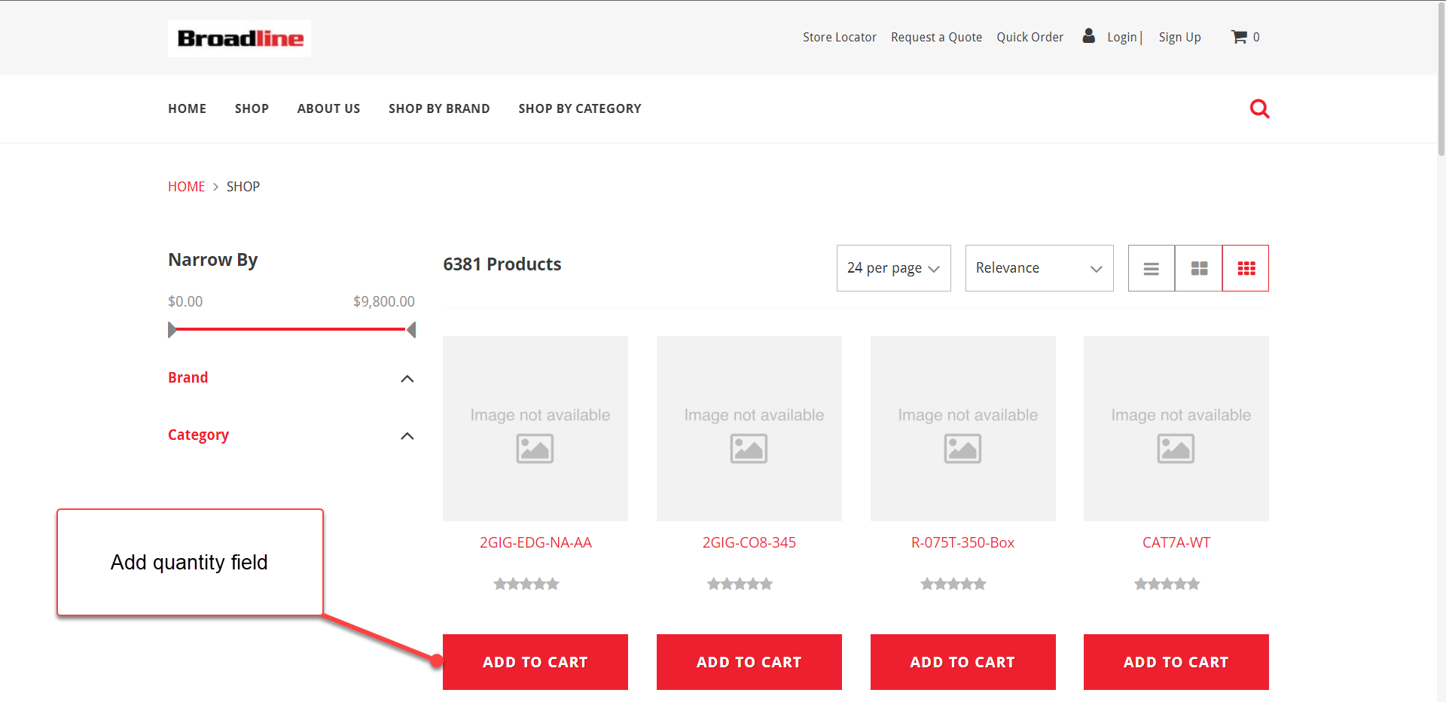
Extension for multiple add to cart, with quantity input.
They also want to show up inventory per location:
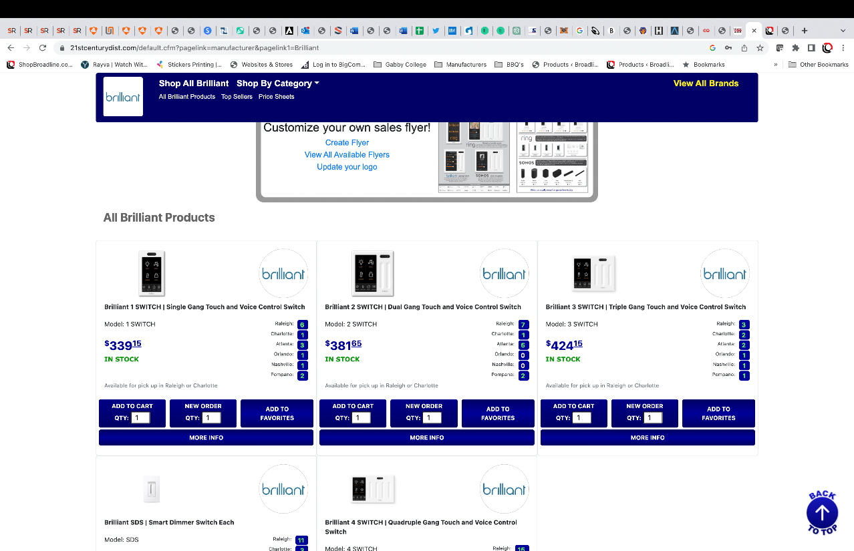
We can add to the template inventory per location via quantity available detail fieldset.

Accessing wish lists
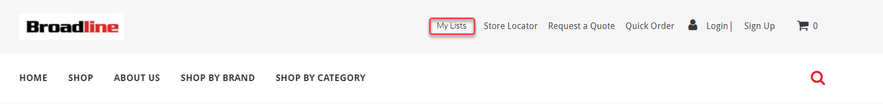

Fields in Product Listing Pages
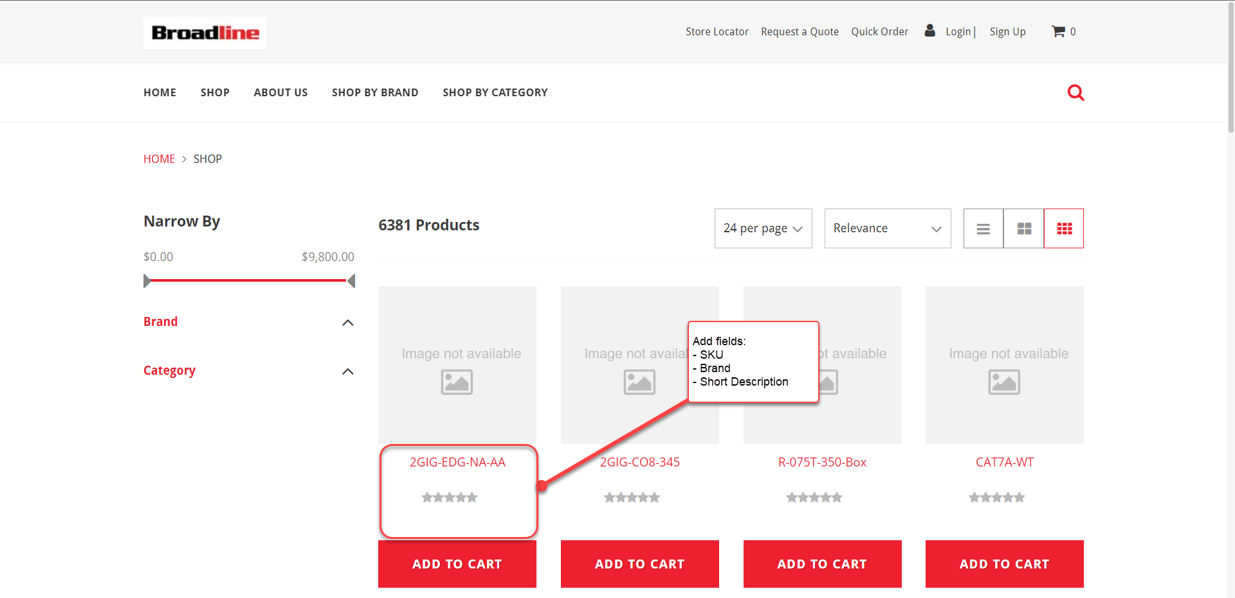

Prerequisites

Assumptions
- Content for Short Descriptions will be provided and set by the client

Constraints and limitations
- This solution won’t work for matrix items.

Risks
- There may be an impact on web performance.

Oracle + NetSuite Professional Services and Customer are in agreement that the information documented above is accurate and representative of the customer’s business needs. This document will act as the basis for all subsequent implementation activities.
Document delivery date: MM/DD/YYYY

